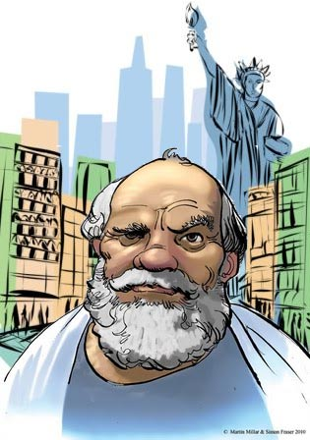
The Socratic Seminar
The things most important in a text; symbols, questions, themes, and images, need to be sought out by the student, not pointed out by the teacher.

The Socratic Method
The Socratic method, named after the classical Greek philosopher Socrates, is a form of inquiry and discussion between individuals, based on asking and answering questions to stimulate critical thinking and to illuminate ideas.

- Preparation
The Socratic Seminar does require preparation. The student must read the selected text, and then write out several discussion starters in the following format:

- Questions
Bring three (3) questions from the selected reading. If there is only one answer to the question then it is not one we want asked in a Socratic seminar. There are three levels of questions. Your questions must be level 3 for credit.

- Plot question (usually these should be answered by research you do before class)
  - If you don’t understand something and think that it might benefit the group for everyone to know we will have 2 students with iPads ready to look things up during the discussion. These questions support discussion but do not count.
- Inference Question
  - These have to do with the reading selection and tend to be questions about motive of the characters, or motive of the author. While these can be great questions, they are still limited to what is in the reading and lack depth of knowledge and therefore do not make good discussion starters.
- Human nature question
  - These questions are less related to the text, but come from what you read. You are on the right track when you start the question, “why is it that humans tend to . . .” These questions fascinate the mind, and could be answered any number of ways. These questions have at least two sides that could be hotly debated, and often have layers and levels that far exceed a simple black and white answer.

B. Answers
After you write you questions you must answer them in a paragraph (11-15 sentences). Since there is not a single correct answer to the question, these answers will be dependant upon:
- Your experience
- Clues about how the author felt (direct quotations are helpful)
- Knowledge of the world and real life instances
- Philosophical understanding of human nature

Quotes or Passages
Chose three (3) selections from the selected reading you believe to be thought provoking and inspire discussion. For credit you must have the passage, the page number and why you chose the passage in your notes. The passages are not discussion starters, but can be used to help support a point you or someone else makes during the discussion. The following are a few reasons to choose a passage:

- The passage was well written and worth sharing
  - These passages can be the ones that give you chills or make you think, the ones that you reread not because you didn’t understand them or because the TV was too loud, but because you want to listen to the words in your head again.
- The passage made me think about . . .
  - These are connections you had to the text, whether from your own life, stories you have read or heard, or from something you have seen in the movies. Connecting to the text shows understanding of human nature.
- The passage shows something about human nature

Discussion
On the day of the discussion you will be graded on whether or not you are properly prepared, and your participation in the discussion. This can be simply paying close attention and taking notes, to being a leader, instigator, devil’s advocate or supporter of others ideas. The quickest way to lose points during a discussion is to be off topic, or having side discussions with others instead of being a part of the whole group.

A few people will have jobs during each discussion:

Leaders: During the day of discussion there will be two leaders, those students selected to keep the discussion moving when it begins to falter or get too far off track. It is not their job to start each thread or to be overly active in the discussion, it is their job to guide the discussion, get those who are not participating a chance to chime in.

Researchers: two students will be armed with iPads and the Internet. Powerful tools at their fingertips, these students will look up statistics, find pictures, look up words or answer sundry other questions that might arise during a Socratic discussion. There is a certain draw to PLAY with the iPad during the discussion, when you are a researcher; I ask that you fight that urge with all of your might.

Socratic Archeologist: One member of the discussion will be noting who speaks and in what order. This will create a web-like pattern on their page as they go from speaker to speaker and back again. At the end you will be able to see how often you spoke, and who spoke most and least often. It is a kind of proof of the validity of our discussion, and can be quite eye opening at times.

During the discussion you will be armed with your notes but you will also be taking notes. If a fellow student asks a particularly interesting question, or reads an interesting passage that you like, write it down. If the discussion leads to enlightenment about the human condition, document it. You never know when something like that might come in handy.

